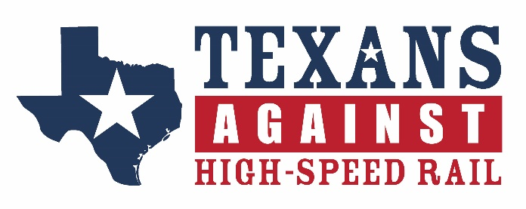
FOR IMMEDIATE RELEASE
March 31, 2022
CONTACT: Desi Burns Porter
EMAIL: desi@TexansAgainstHSR.com
TEXAS HSR PROMOTER OWES $622,000+
IN DELINQUENT PROPERTY TAXES
Texas HSR project is delinquent on its property taxes in all counties in which it owns property and continues to incur interest and penalties.
Jewett, Texas – Related to James Miles v. Texas Central Railroad and Infrastructure before the Supreme Court of Texas, the Counties of Ellis, Freestone, Grimes, Leon, Limestone, Madison, Navarro, and Waller submitted a letter yesterday to the Court to update them on the significant growing amount owed by Texas Central to those counties, as well as Dallas and Harris Counties, in delinquent 2021 property taxes.
Despite making regular public claims that the company would benefit the counties by being “responsible neighbors” and “substantial tax payers,” Texas Central owes the counties in which it owns property over $622,000, including $216,359 to Harris County and nearly $146,000 to Grimes County, and these amounts continue to grow as interest and penalties grow with the delay in payment. Ellis County is correcting erroneously assessed taxes for all years Texas Central owned properties in the county, which will likely bring the total closer to $1 million.
Amounts owed to Counties by Texas Central:
Dallas $29,898.26
Ellis TBD
Freestone $18,051.64
Grimes $145,982.39
Harris $216,359.85
Leon $3,942.30
Limestone $10,055.35
Navarro $17,890.74
Madison $68,978.33
Waller $111,817.12
Total = $622,975.98
Waller County Judge Trey Duhon offered, “We felt it was important to share this telling information with the Supreme Court of Texas…Texas Central would have the Court believe that they are capable of building a $30B project and should be entrusted with the enormous power of eminent domain authority…yet, the truth is that they are incapable of doing something that responsible property owners must do every year—simply pay their property taxes.”
While the amount of property currently owned by Texas Central is a small fraction of 9,000 acres needed for the proposed HSR project and does not include the proposed station locations, these delinquent taxes seem to stem from the company’s current financial state, which would be fully revealed in its required application for a construction permit from the Surface Transportation Board (STB). As such, the Counties also updated the Court that two years have now passed since the STB denied the company’s request to bypass a full application and no work has begun on the application for a construction permit.
###

